Wilson Baseball
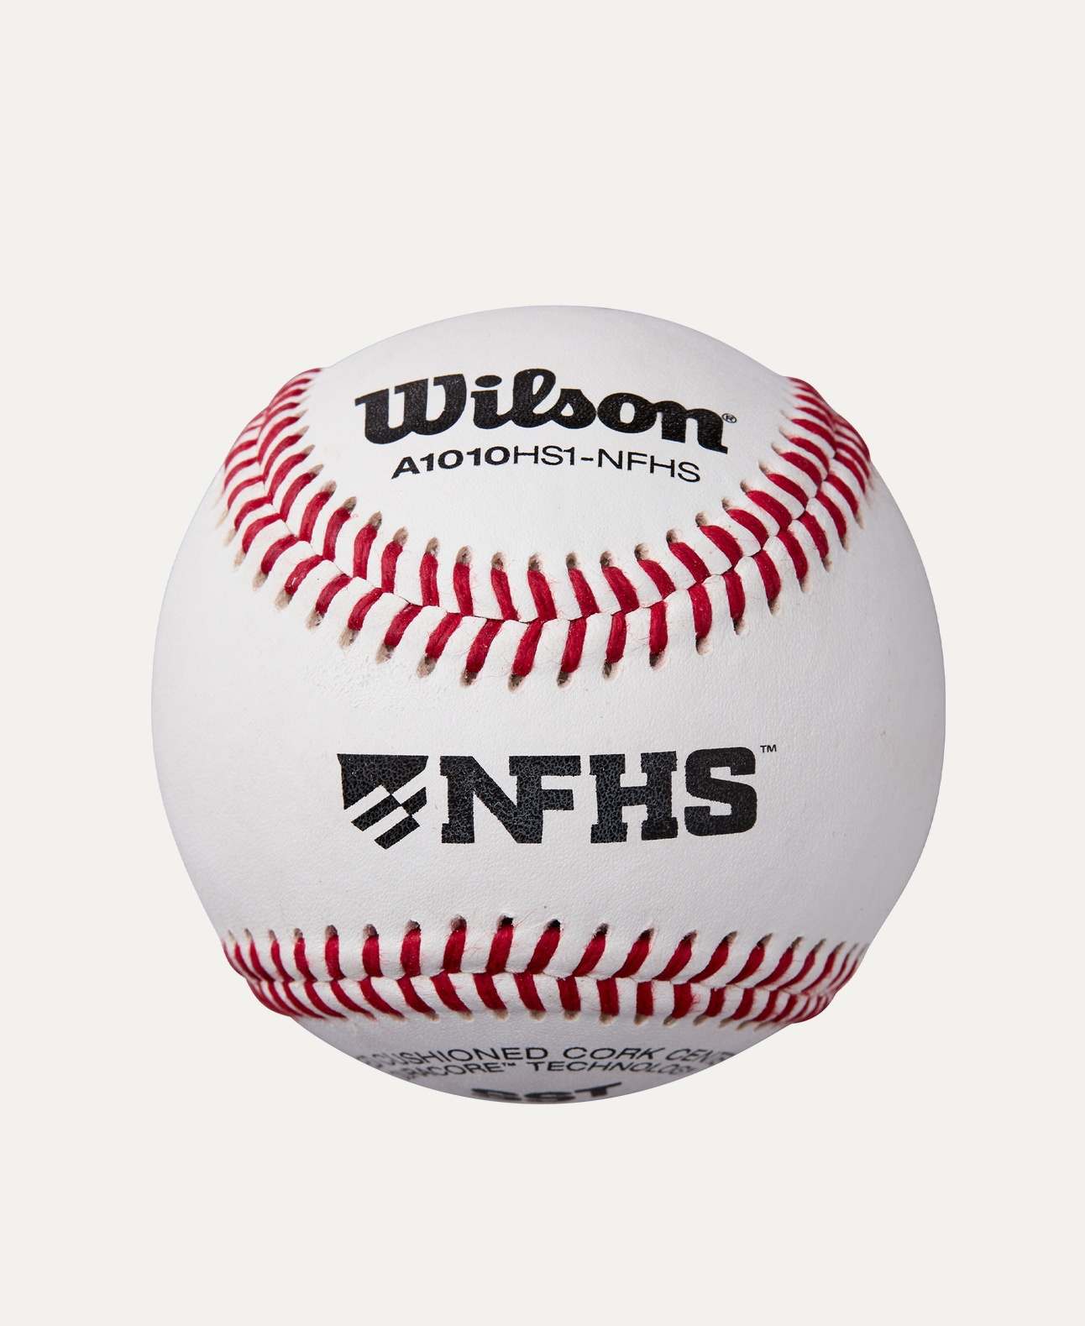
Price: Approximately Rs 55,000
Introduction
The Wilson Baseball is designed to deliver consistent performance, durability, and control for players at all levels. Suitable for training and competitive play, it meets high-quality standards trusted by athletes worldwide.

Product Overview
This Wilson Baseball is crafted to provide reliable grip, accurate flight, and long-lasting use. Its balanced construction makes it ideal for practice sessions, league matches, and academy training.

About the Brand
Wilson is a globally recognized sports brand known for producing premium-quality sports equipment. Wilson baseballs are widely used in professional leagues, schools, and sports academies for their consistent performance.

Key Features
- Consistent shape and weight
- Strong stitched seams for better grip
- Reliable performance during play
- Suitable for training and match use
- High-quality construction

Design & Build Quality
The baseball features traditional red-stitched seams with a smooth, well-finished surface. Its solid core ensures stable performance and accurate pitching and hitting.

Storage & Capacity
Compact and easy to store, the baseball fits conveniently in sports bags, buckets, or storage boxes without losing shape.

Material & Durability
Made from a durable rubber or cork core with a synthetic or leather cover (model dependent), the Wilson Baseball is built to withstand repeated hits and throws.

Ideal For
- Beginner to professional baseball players
- Training academies and schools
- Practice sessions and matches
- Indoor and outdoor fields

Care Instructions
- Keep dry when not in use
- Clean with a soft, dry cloth
- Avoid prolonged exposure to moisture
- Store in a cool, dry place

Product Specifications
- Brand: Wilson
- Product Type: Baseball
- Core Material: Rubber / Cork
- Cover Material: Leather / Synthetic
- Stitching: Reinforced red seams
- Usage: Training & Match Play

Product Summary
The Wilson Baseball offers dependable performance, durability, and quality construction. Whether for practice or competitive games, it is a reliable choice backed by Wilson’s trusted sports expertise.

Thank you

